OUTPUT SCREENSHOTS :

SPRING SECURITY :

1.SECURITY CODE GENERATION :

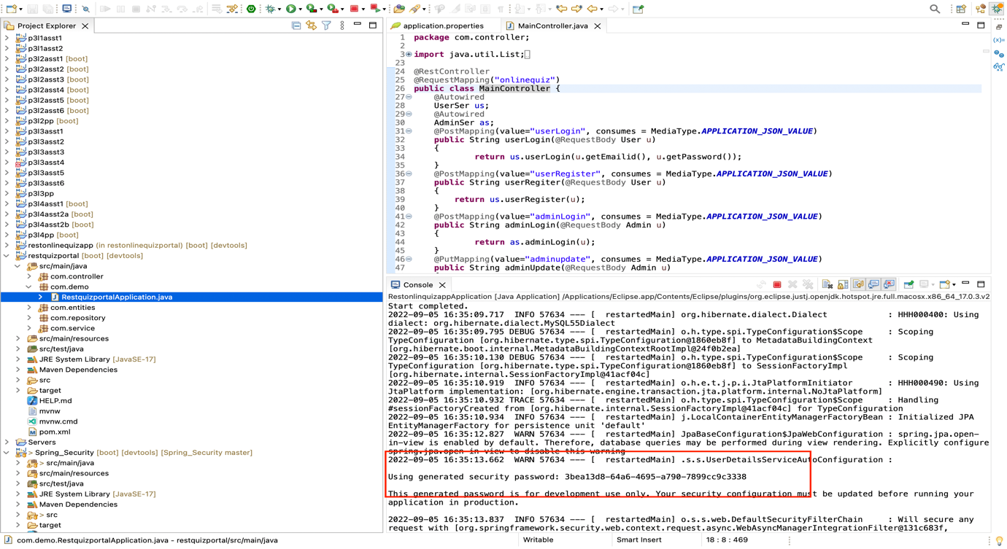

2.LOGIN PAGE :

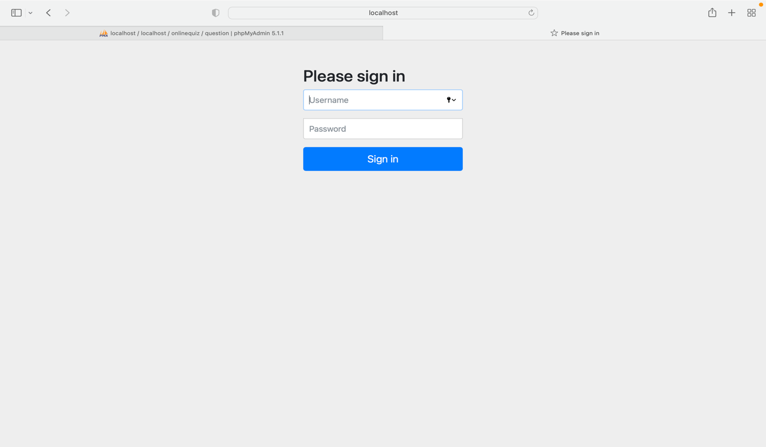

2A.INVALID CREDENTIALS :

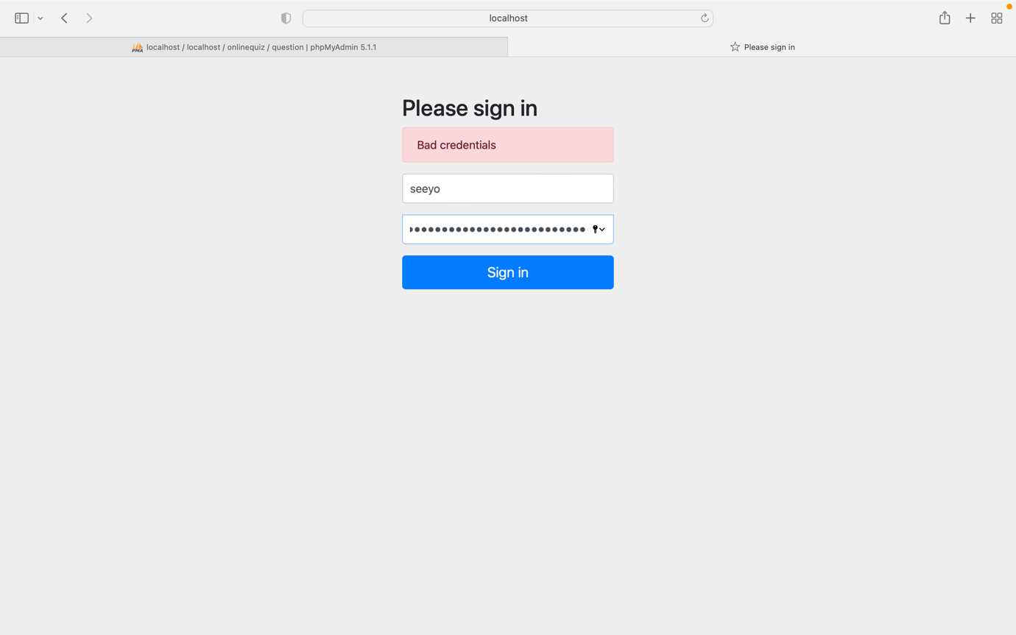

2B.VALID CREDENTIALS :

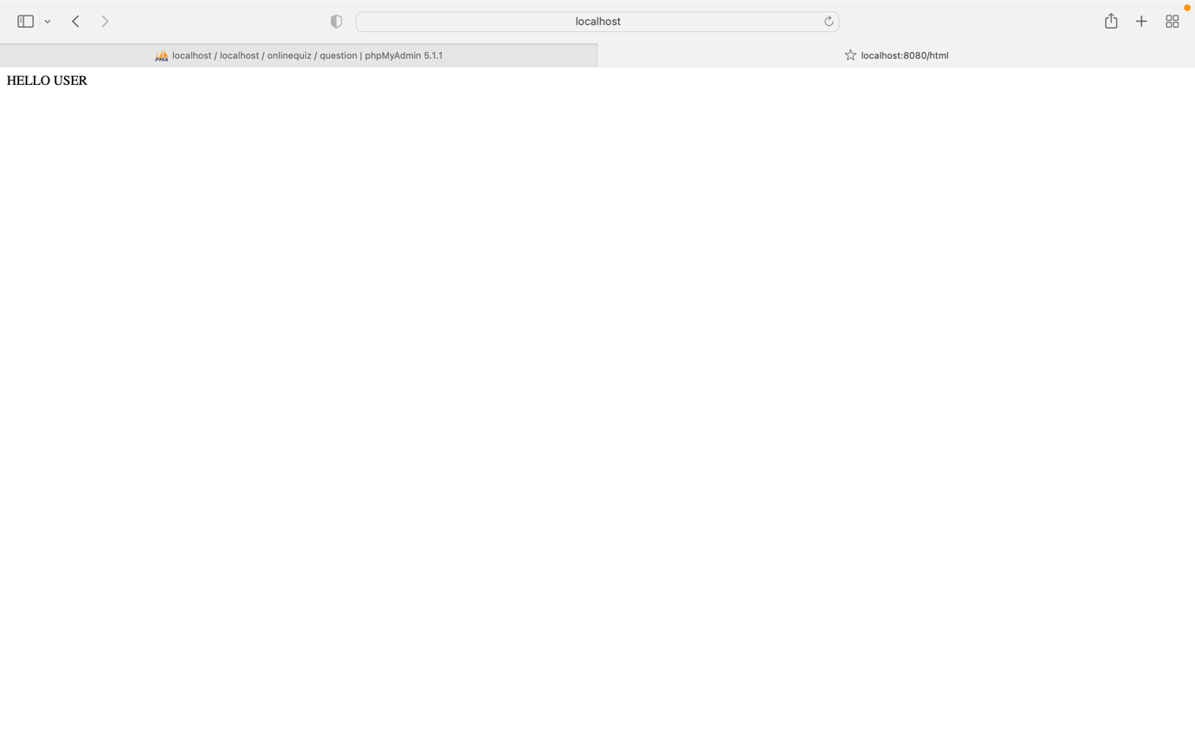

ADMIN MODULE :

3.ADMIN DATABASE :

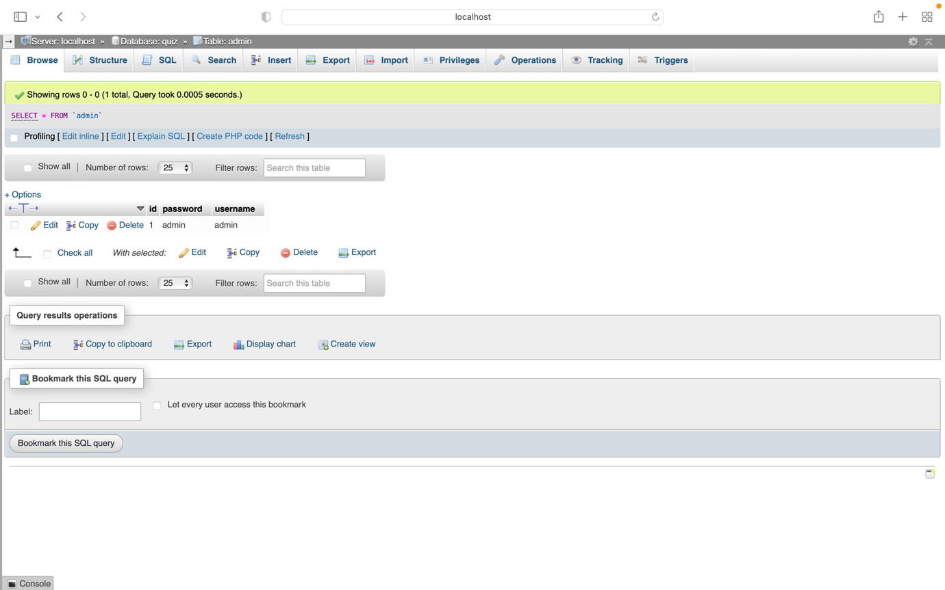

4.ADMIN LOGIN :

4A.INVALID ADMIN LOGIN CREDENTIALS :

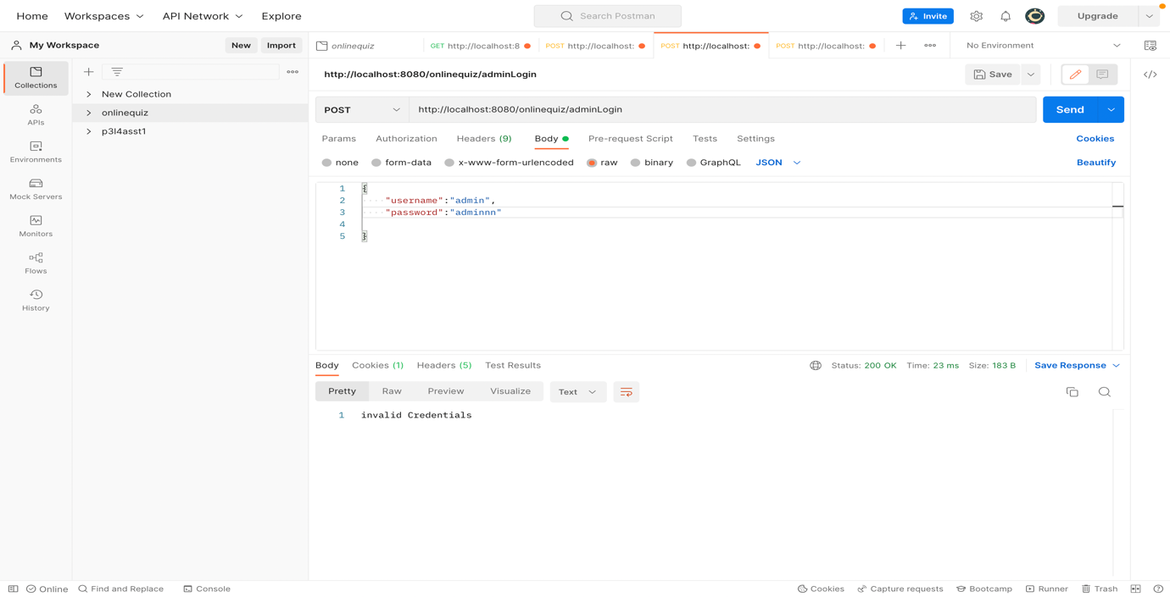

4B. VALID ADMIN LOGIN CREDENTIALS :

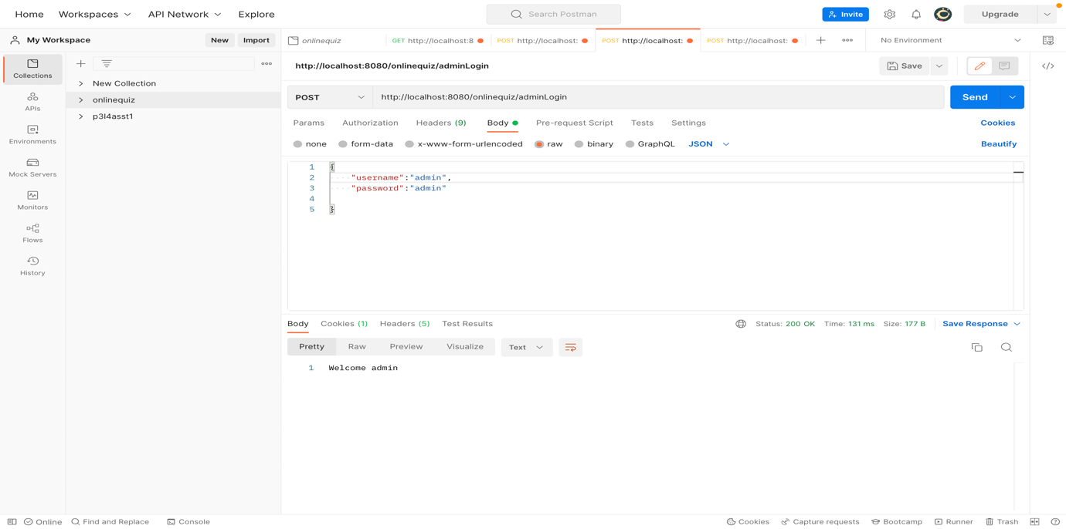

5.UPDATE ADMIN CREDENTIALS :

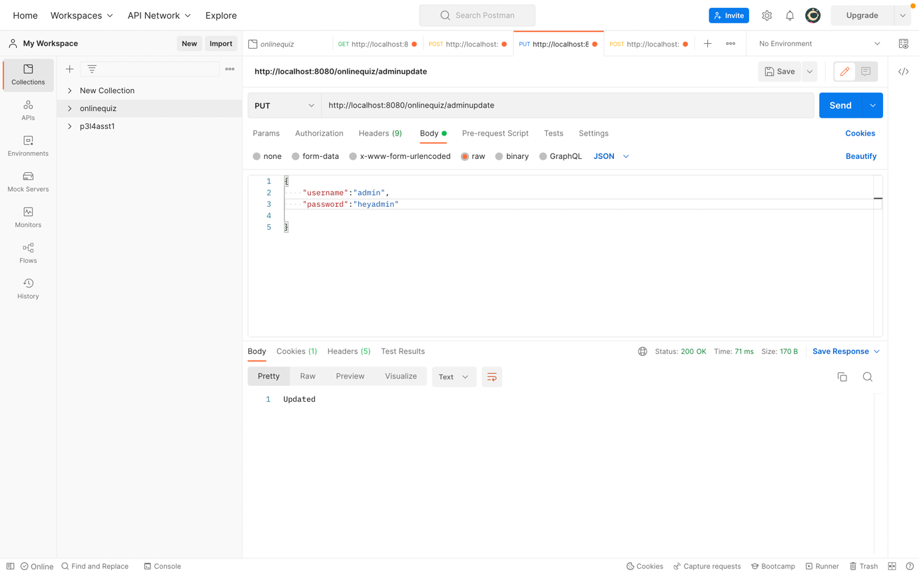

6.DATABASE AFTER UPDATION OF ADMIN CREDENTIALS :

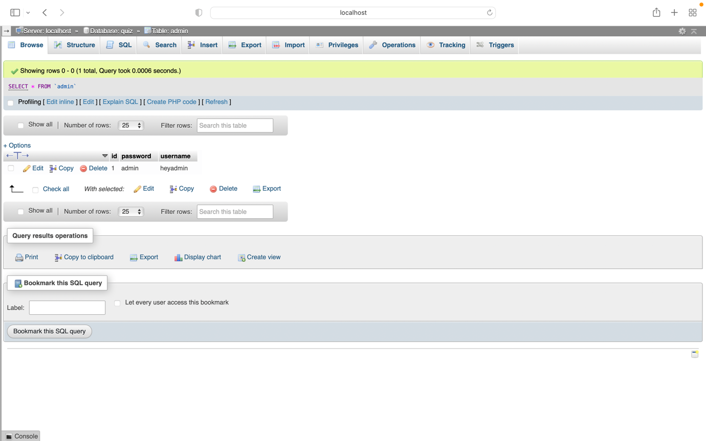

7. QUESTIONS TABLE:

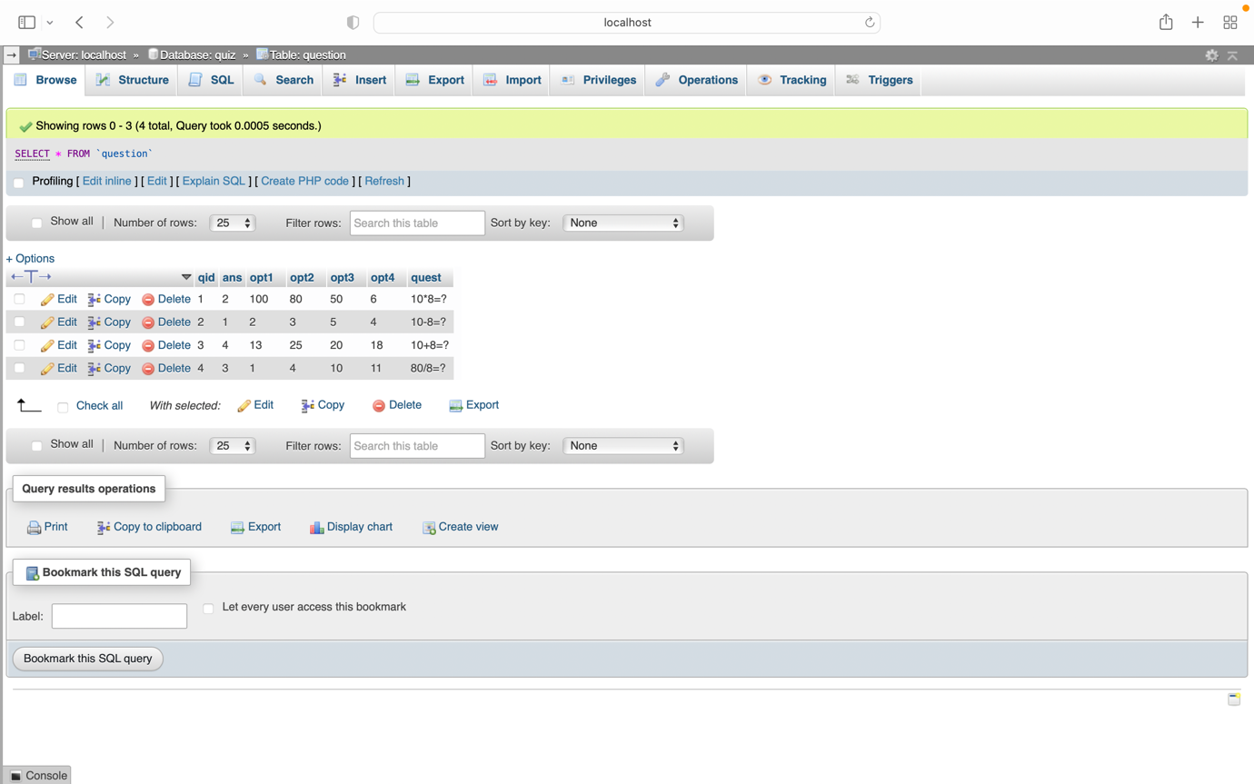

8.INSERT QUESTIONS :

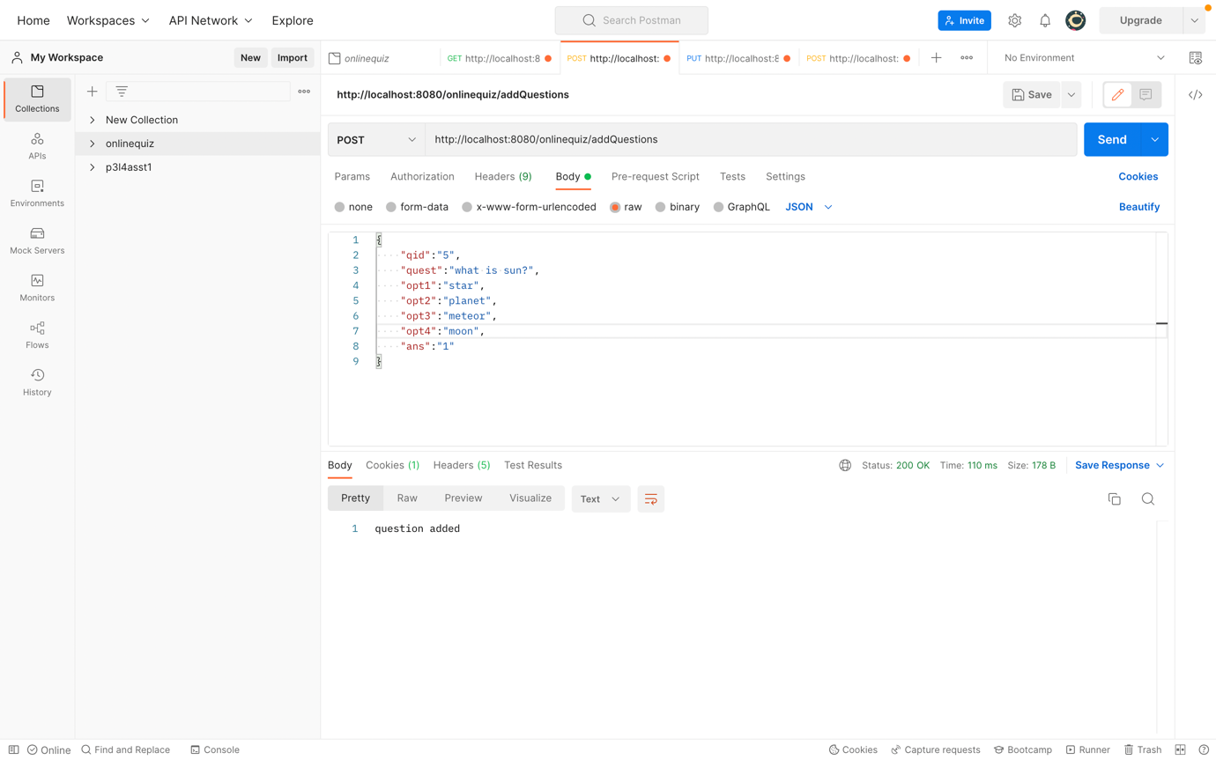

9.DATABASE AFTER INSERTION OF QUESTIONS :

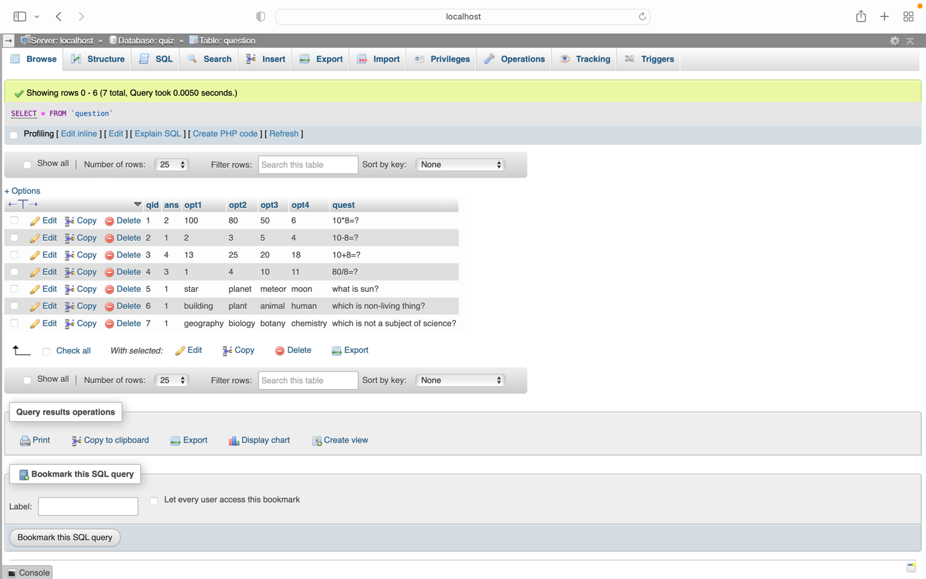

10. QUIZ TABLE :

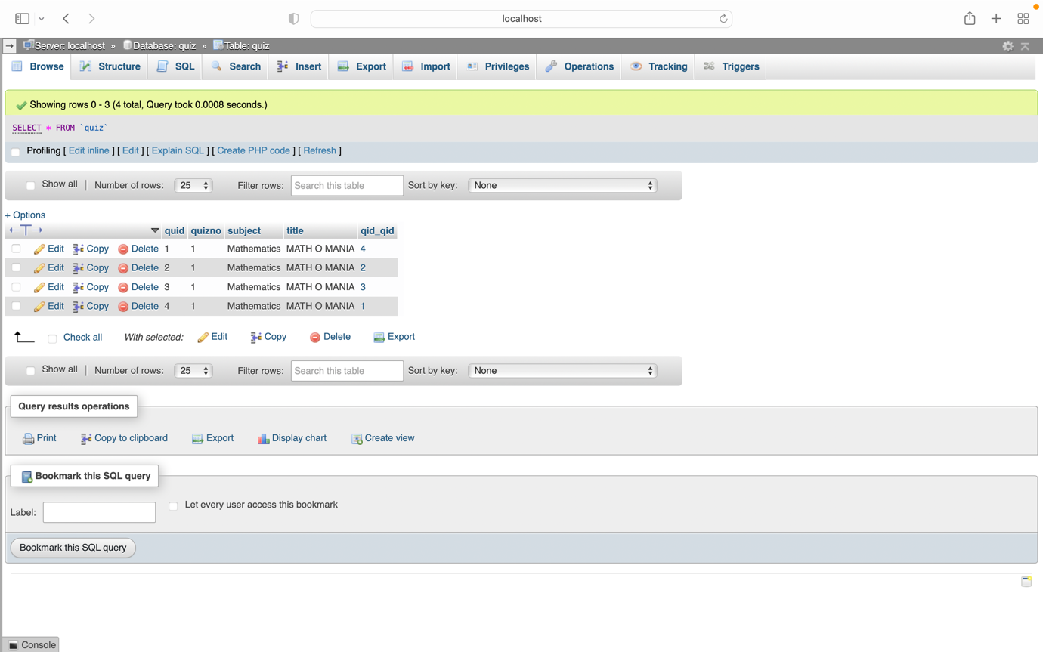

11. CREATE A NEW QUIZ :

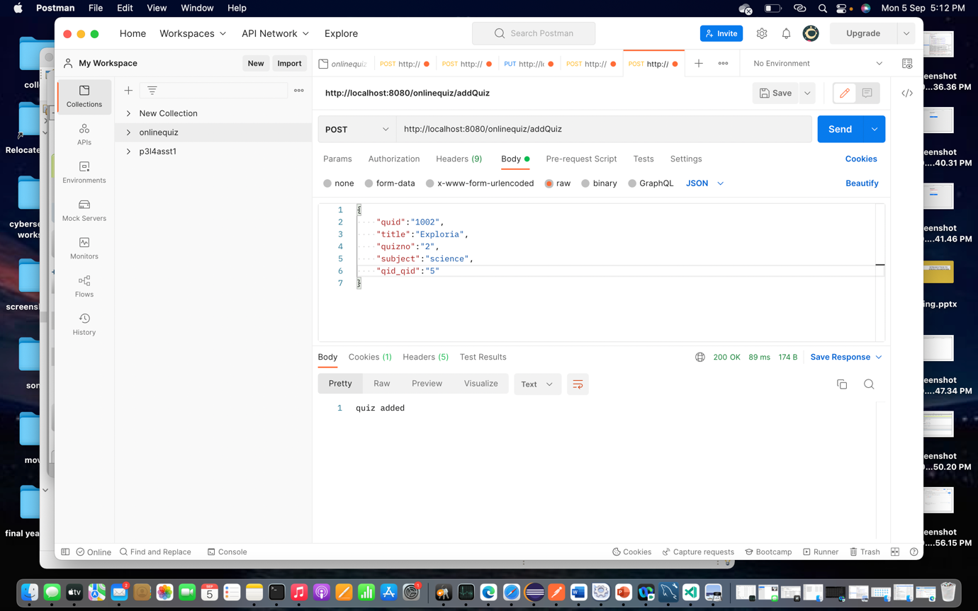

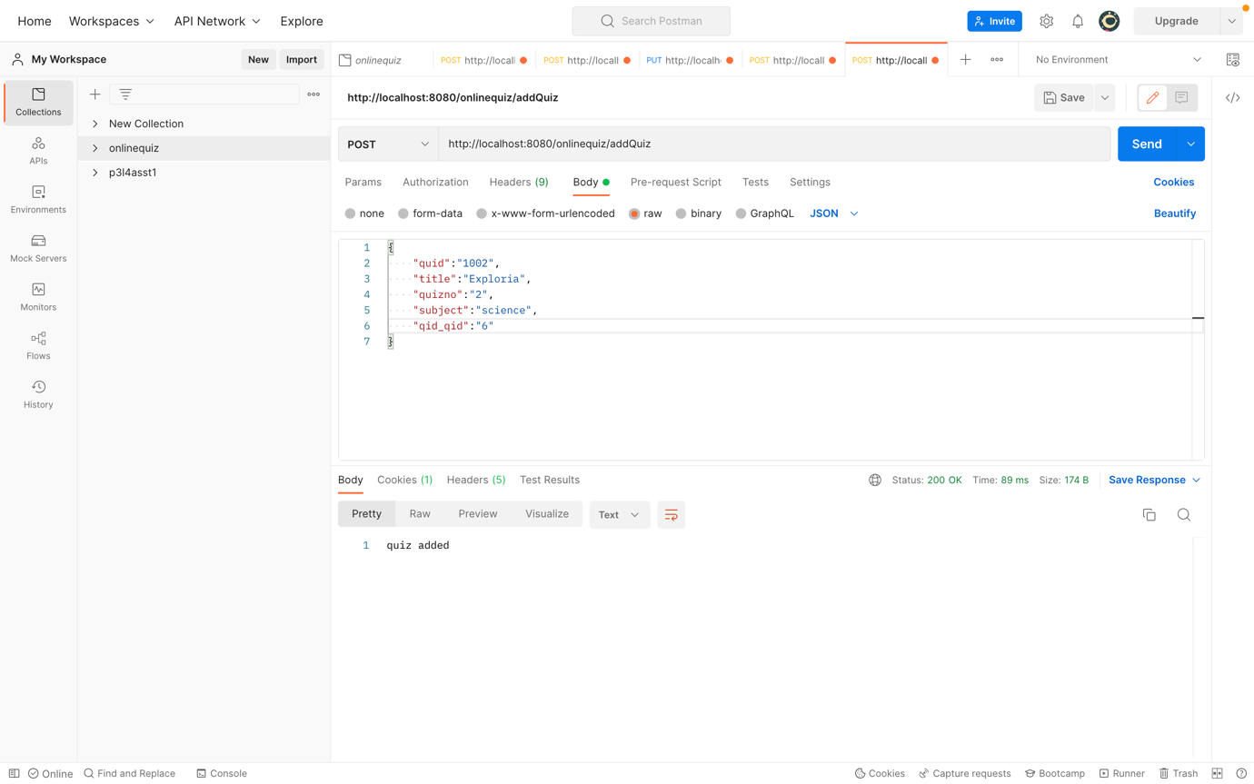

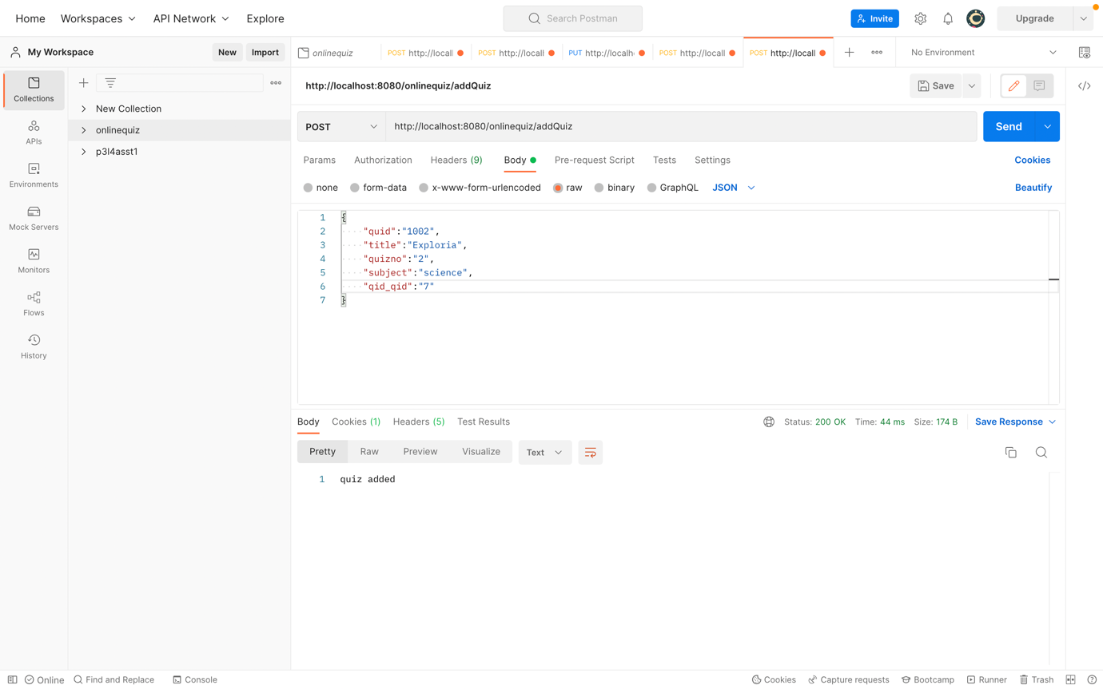

12. QUIZ TABLE AFTER ADDING A NEW QUIZ:

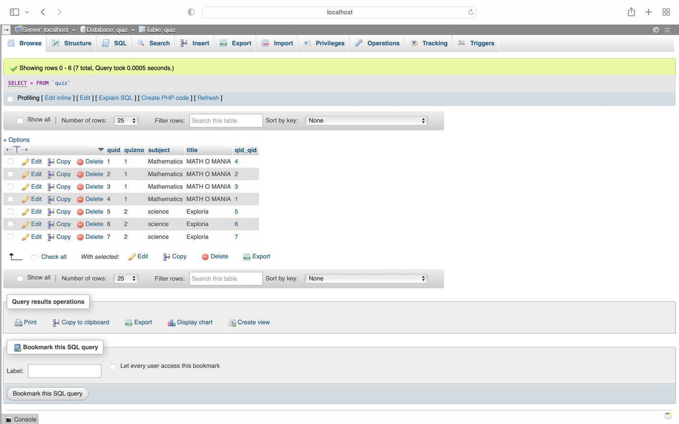

13.VIEW ALL QUIZ WITH ANSWER KEY :

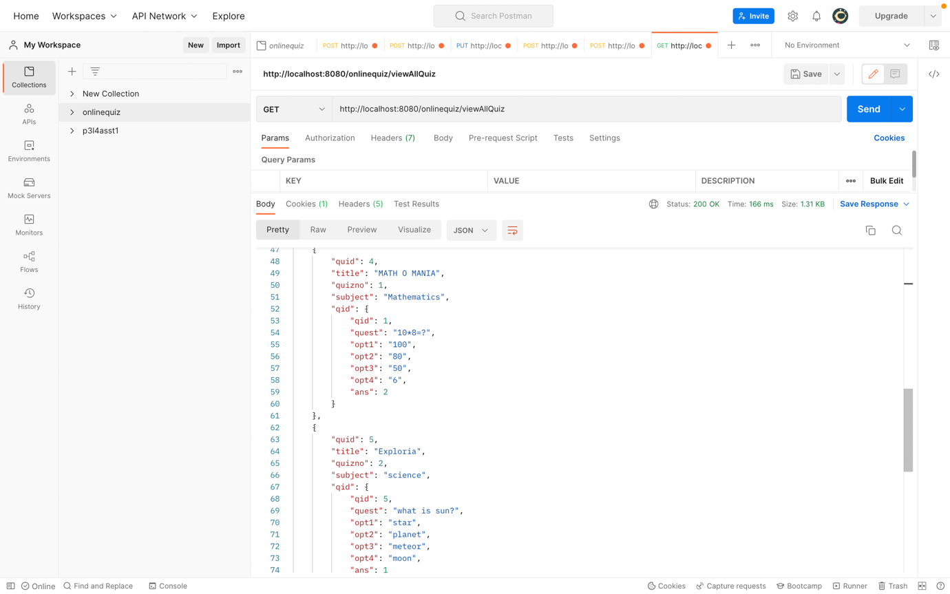

14. VIEW TOTAL USERS, QUIZ AND QUESTION COUNT :

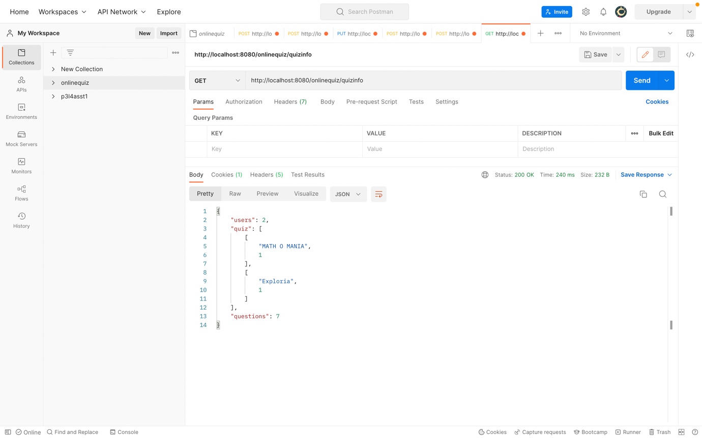

15. VIEW SCOREBOARD :

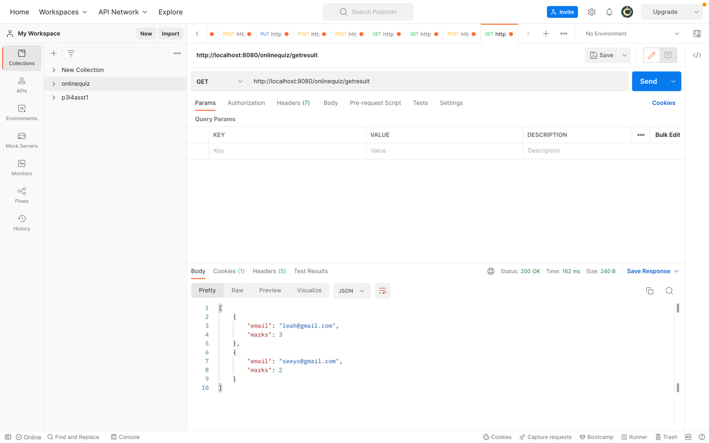

USER MODULE :

16. USER TABLE :

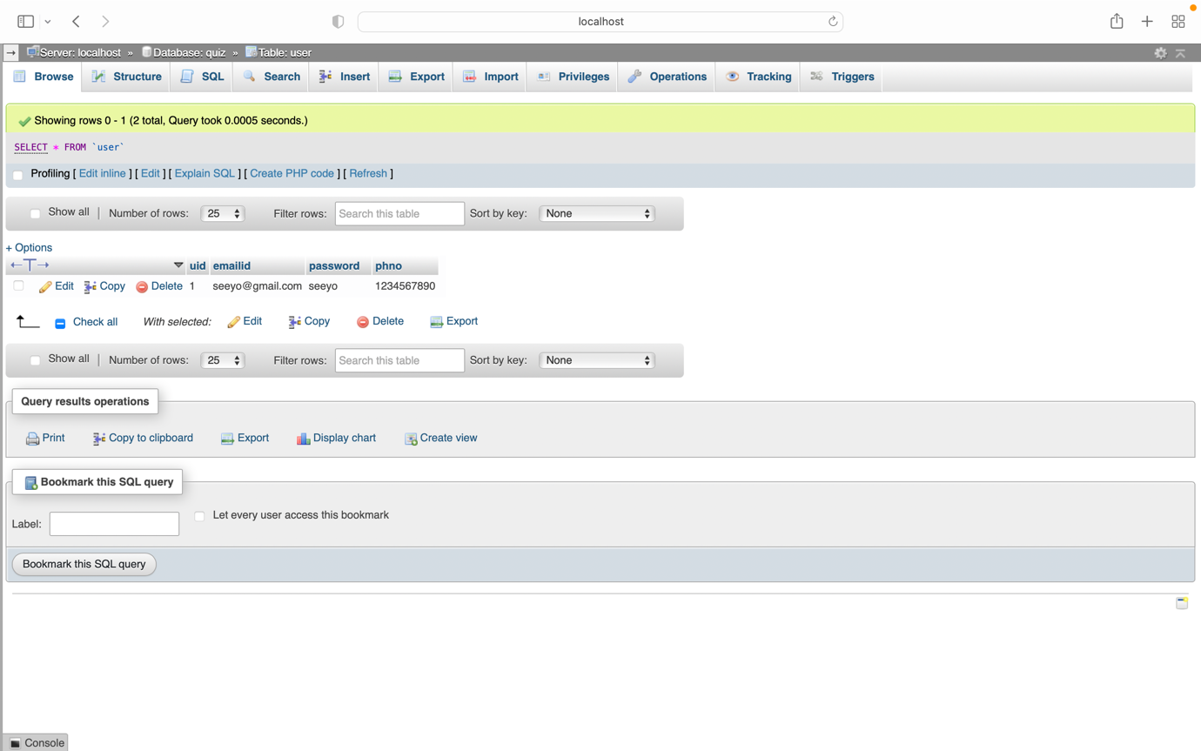

17.REGISTER USER :

17A. USER ALREADY REGISTERED :

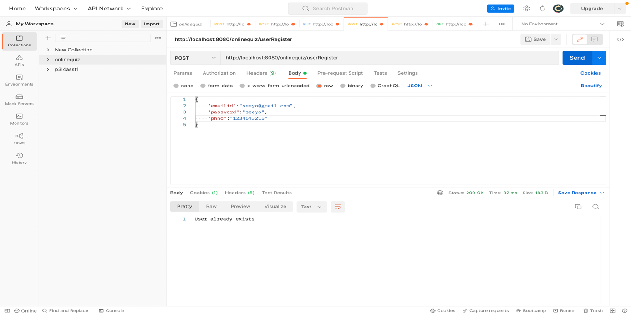

17B.NEW USER REGISTERED SUCCESSFULLY :

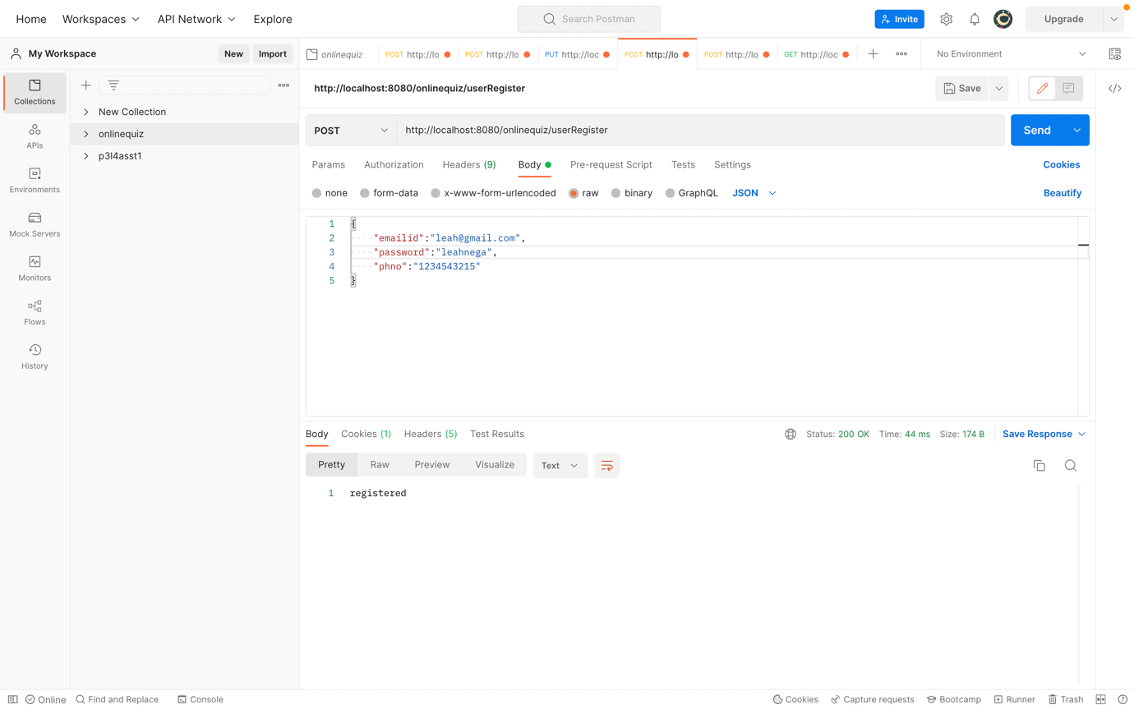

18.USER TABLE AFTER REGISTERING NEW USER :

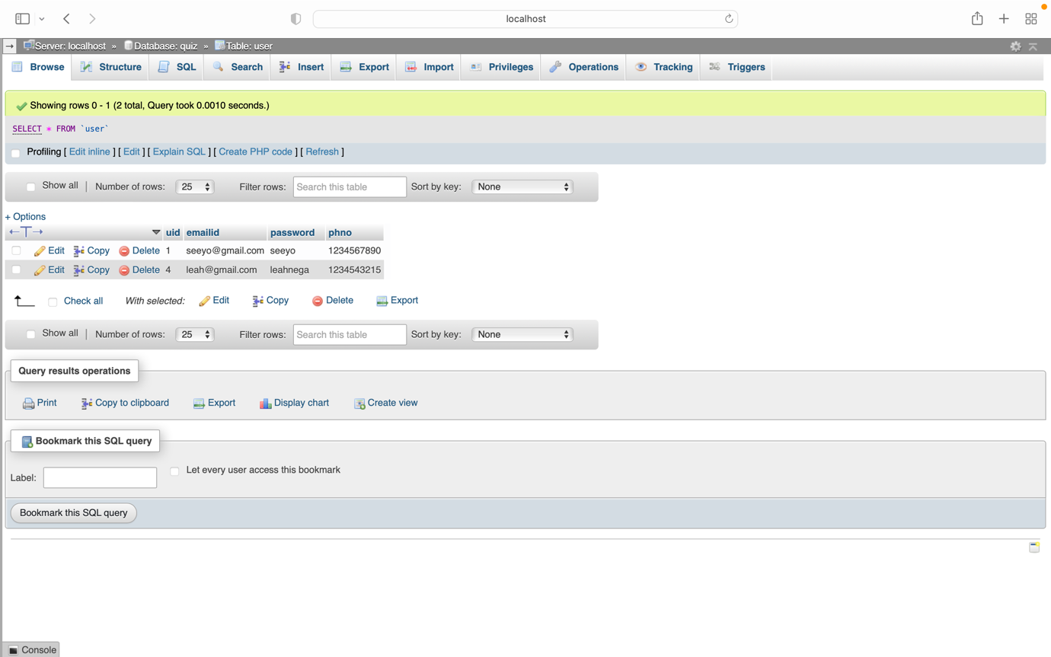

19.USER LOGIN :

19A.USER LOGIN WITH INVALID CREDENTIALS :

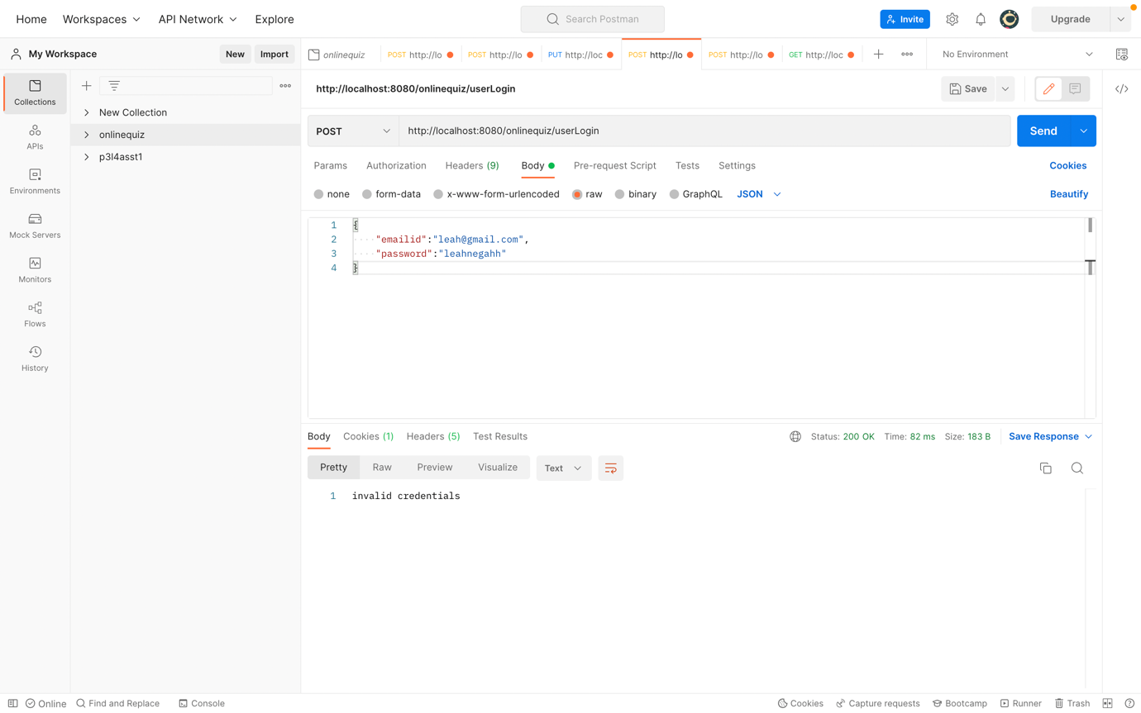

19B.USER LOGIN WITH VALID CREDENTIALS :

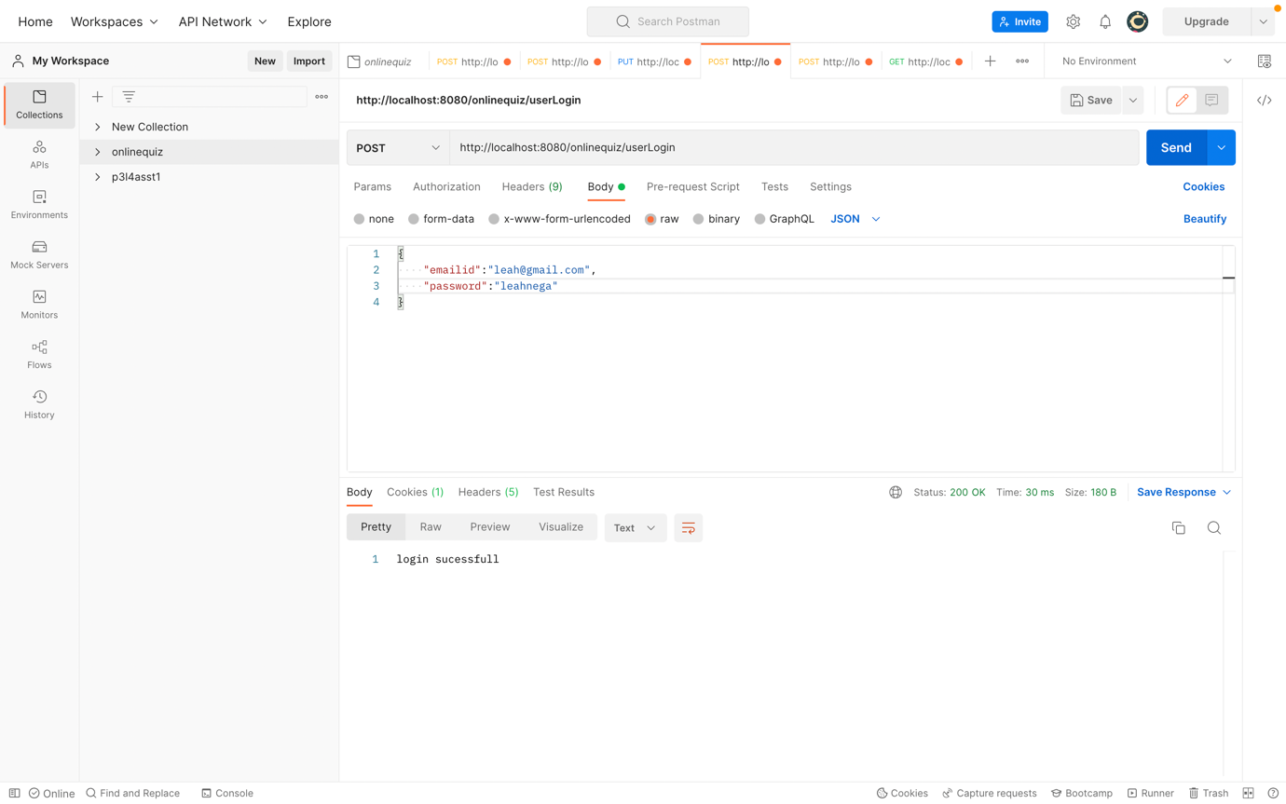

20.VIEW AND SELECT TEST :

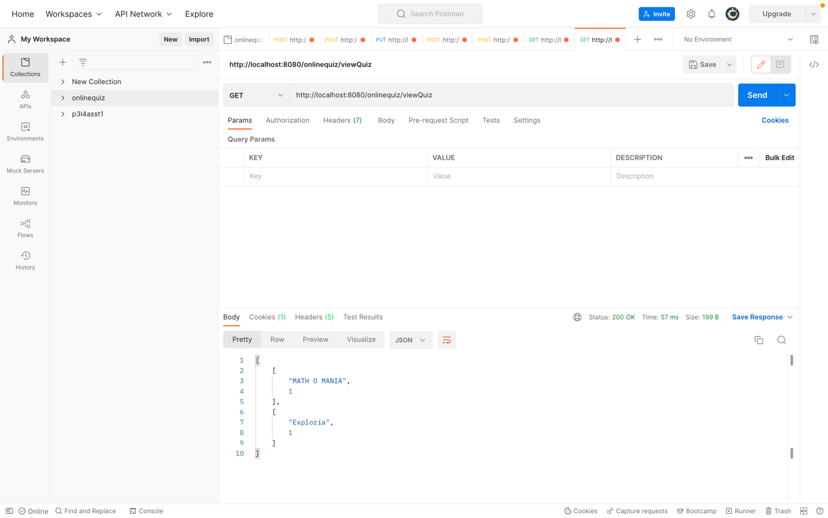

21.ATTEMPT TEST :

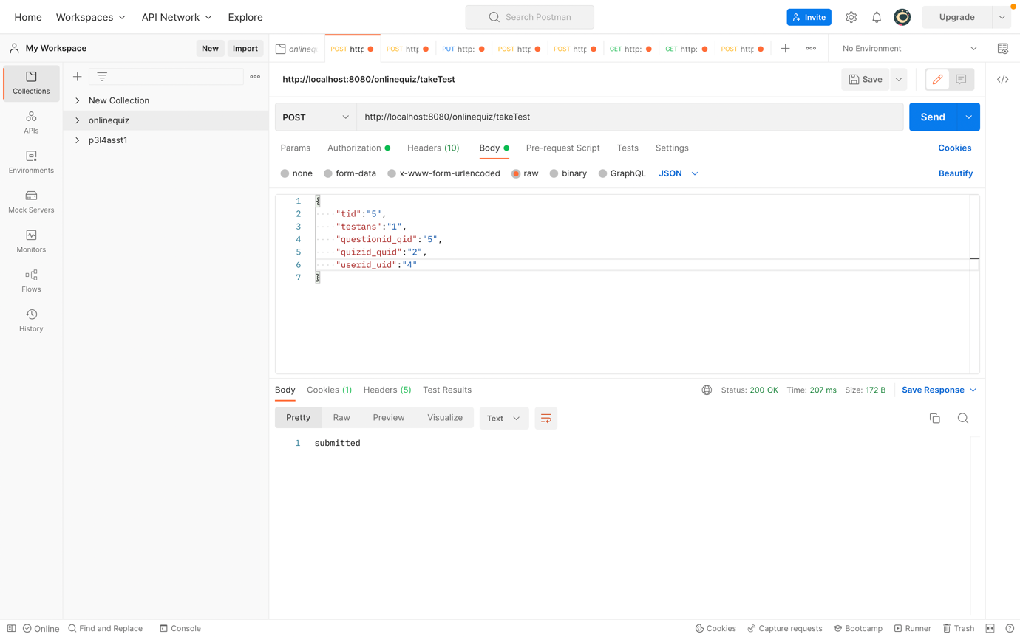

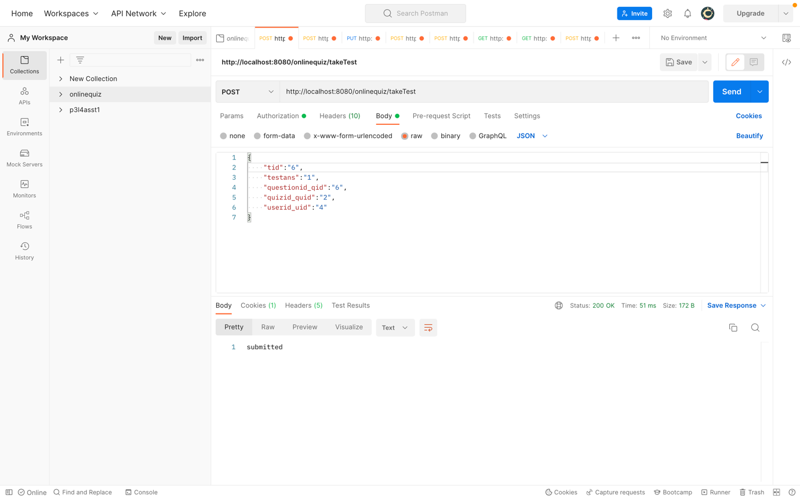

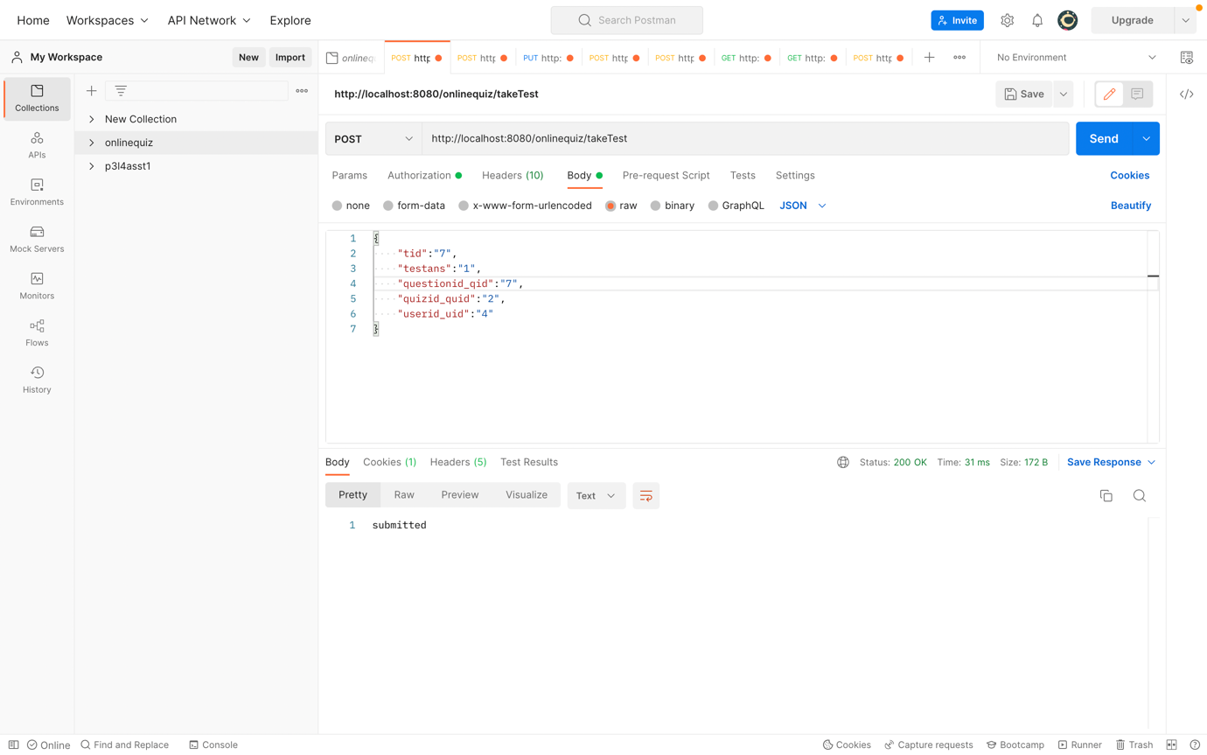

22. VIEW YOUR SCORE AND PLACE IN SCOREBOARD :

